Outline for e-Training (Template)
Title
Subtitle
This template intends to guide the documentation of educational solutions that support teaching and learning in a cost-effective way.
It may serve project teams to reflect on different possibilities, to discuss, design, plan and budget solutions, as a basis for the select educational technologies.
Place, date …
Content
1 Situation 3
1.1 Project goals 3
1.1.1 Purpose 3
1.1.2 Intervention area and scope 3
1.2 Context: Potential and restrictions 3
1.2.1 Organization 3
1.2.2 People 3
1.2.3 Infrastructure and Technology 3
1.3 Use case 3
1.4 Theory of change 4
2 Digital Educational Solution 5
2.1 Learning Goals and Skills 5
2.2 Learning/teaching activities 5
2.3 Digital Educational Solution 6
2.4 Applications. 6
2.5 Hardware 6
2.6 Connectivity 6
3 Organisation and Planning 7
3.1 Project team and partners 7
3.2 Project phases 7
3.3 Budget 7
3.4 Risk management 7

Abbreviations
DET Digital Educational Technologies
ICT Information and Communication Technologies
… …
… …

Situation

Project goals

Purpose
- Analyse needs and strategic goals (See e-Training Guide, chapter 1.1)

Intervention area and scope
- Describe educational offer (subjects, form of training) to be supported by DET
- Analyse the eco-system
- Describe scope (approximate number of colleges, trainers, students, businesses etc.)

Identify possible approaches
Identify possible approaches (See e-Training Guide, chapter 1.2)

Context: Potential and restrictions
- Describe the potential and restrictions of the above intervention area regarding People/HR, Organization and infrastructure/technology of the involved organisation(s) and their environment. (See e-Training Guide, chapter 1.3; ICT4TVET decision matrix, Appendix )
To inform the design of cost-effective and sustainable educational solutions the following context-factors are taken into consideration.

Organization
Describe …
- Management support and resources (budget, manpower, infrastructure etc.)
- Training organisation
- Geographical distribution
- Organisational culture and experience with innovation

People
- Describe stakeholder-specific skills, experience and attitudes
(students, trainers, directors, staff, etc.)

Infrastructure and Technology
Describe access of all the stakeholders to …
- Infrastructure of institutions (hardware applications, software-architecture, interfaces, electricity/network access and restrictions, e-content)
- Hardware and applications of users and their contacts (% use of potential users, distinguish different profiles, e.g. rural women, urban-rural differences etc.)

Use case
Describe …
- a scenario with the relevant actors (students, teachers, support staff etc.), their characteristics and intentions.
- Preconditions of the situation in the beginning, “triggers” that initiate the flow of events which leads to post-conditions after the goal has been reached.
- a series of interactions (flow) leading to specific events (provision of DET, learning etc.), handling exceptions (technical and organisational difficulties) to reach their goals.

Theory of change
(see ICT4VET impact model.pptx)
Discuss and explain how you plan to achieve an impact
- Activities, e.g. training support, procurement of HW/SW, technical support, e-content production
- Outputs, e.g.: train-the-trainer programmes, coaching offer, tablets, servers, platforms, high quality e-content
- Outcomes, e.g. improved teaching and coaching practice, using e-content adequately in class / self-directed learning, participatory learning, improved learning results, improved pass rates
- Impact, e.g. increase of work productivity, improvement of workforce

Digital Educational Solution
(See e-TVET Landscape)

Learning Goals and Skills
Describe the goals that you aim to help to achieve with the digital educational solution, based on the curriculum, such as …
- Cognitive learning goals
- Socio-emotional skills
- Psycho-social skills
- …

Learning/teaching activities
Describe the activities of students and teachers to achieve these goals in different contexts:
In the classroom …
Students
- …
Teachers support the students by …
- …
In workshops on campus or in companies, they …
Students
- …
Teachers support the students by …
- …
In self-directed learning, they …
Students
- …
Teachers support the students by …
- …

Visualize the main learning activities to engage in different forms of interaction with the help of the e-TVET Landscape.

Digital Educational Solution
Describe the digital educational technologies that support the learning and teaching activities.

Applications
Applications that support learning, teaching and coaching, such as …
- Learning platform(s)
- Synchronous/asynchronous collaborative tools
- Social media
- Drill&Practice applications
- VR/AR-tools
- AI-supported tools
- …
The e-TVET Landscape can be used to describe how these technologies help students to engage in different forms of interaction and to reach different learning goals).
Applications that support e-content production and management, such as …
- Authoring software
- Content management software
- …
Interfaces to further components in the IT-architecture of the participating institutions, such as …
- School management systems
- Repositories
- …

Hardware
Describe the hardware that will be needed for an inclusive and equitable learning/teaching/coaching by students, teachers, business coaches etc., such as …
- Devices to access the applications: Tablets, smartphones, etc.
- Servers to host platforms and applications
- Hardware for e-content production (AV-production equipment)
- ….

Connectivity
Describe the connectivity that will be needed for an inclusive and equitable learning/teaching/coaching by students, teachers, business coaches etc., such as …
- WLAN networks in colleges, workshops etc.
- Mobile networks for access from homes, businesses etc.
- …

Organisation and Planning

Project team and partners
Define roles and tasks of project members and partners (Name, competences, professional profile)

Project phases
Define project phases and activities with clearly defined milestones, such as …
  - Planning and preparation
  - Setting up/customizing infrastructure
  - Training, support and coaching of trainers, business coaches, directors, administrative staff
  - Production of e-content
  - Piloting: Training, supporting, testing and improving
  - Ongoing monitoring and evaluation
  - Up-scaling
General tasks:
  - Project management
  - Information management, Knowledge management
  - Controlling
  - Quality assurance, monitoring and evaluation

Budget
Create the budget based on the scope, recommended solutions and project activities (see ICT4TVET Costing framework).

Risk management
Based on the defined goals, solutions and context analysis, discuss and define expected risks and needed countermeasures to foster inclusion, privacy, sustainability etc.
Risk | Probability (high, middle, low) | Effect (high, middle, low) | Background information  Countermeasures
…

Appendix

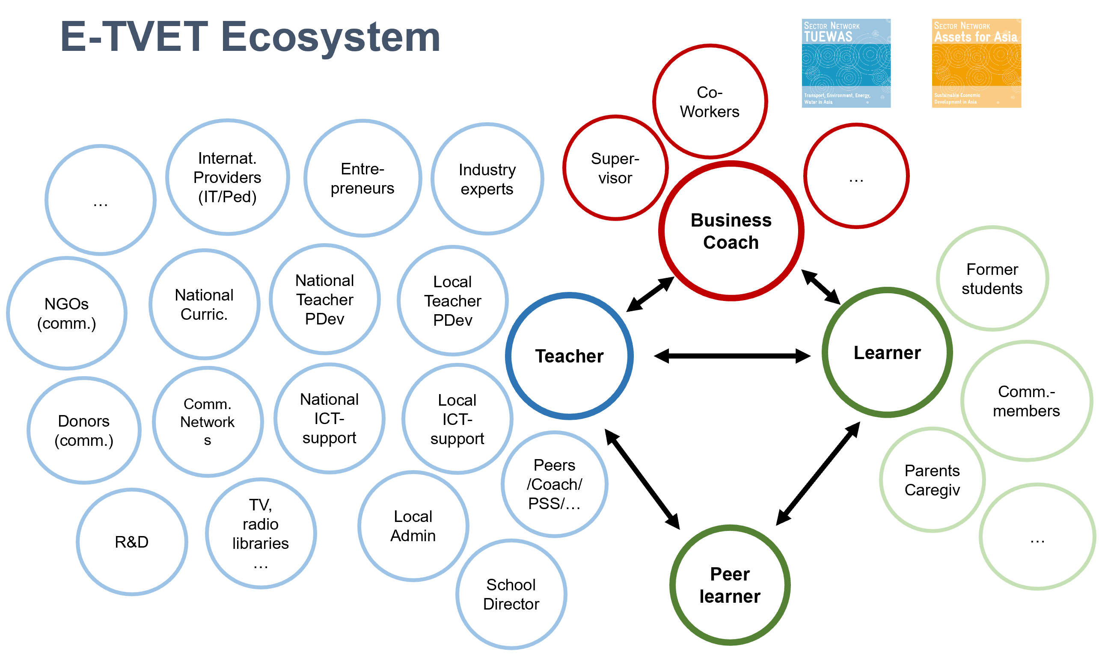
A) e-TVET eco-system

B) ICT4TVET Decision Matrix
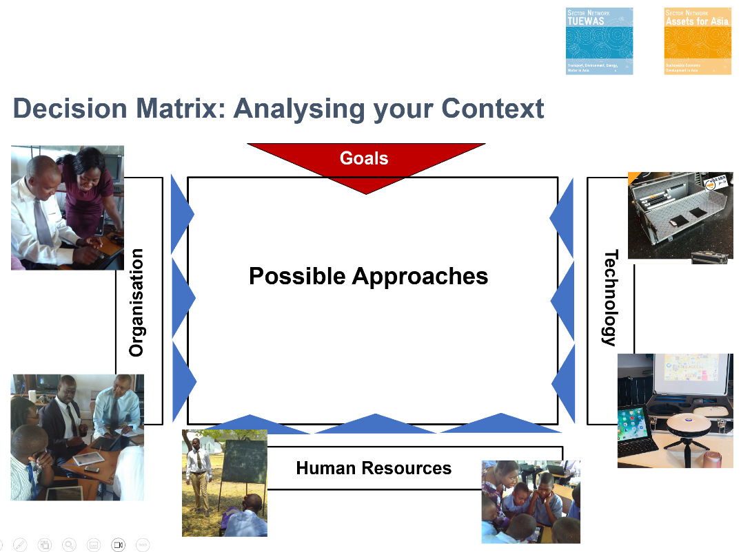

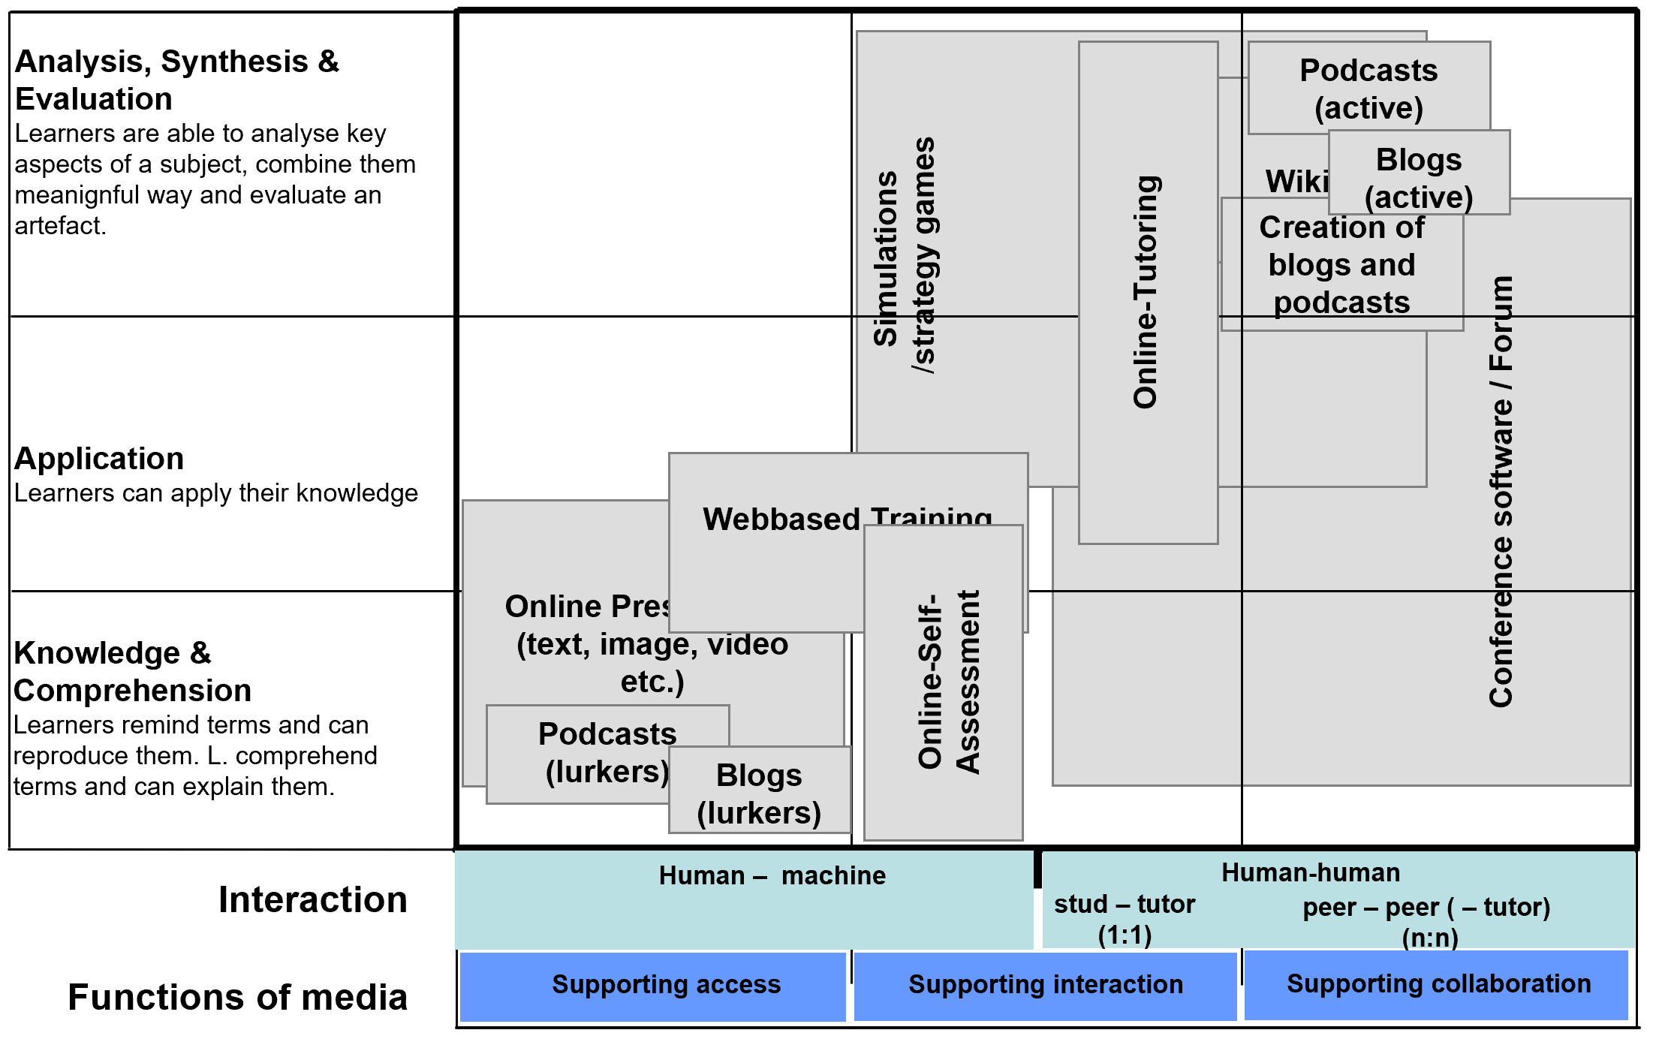
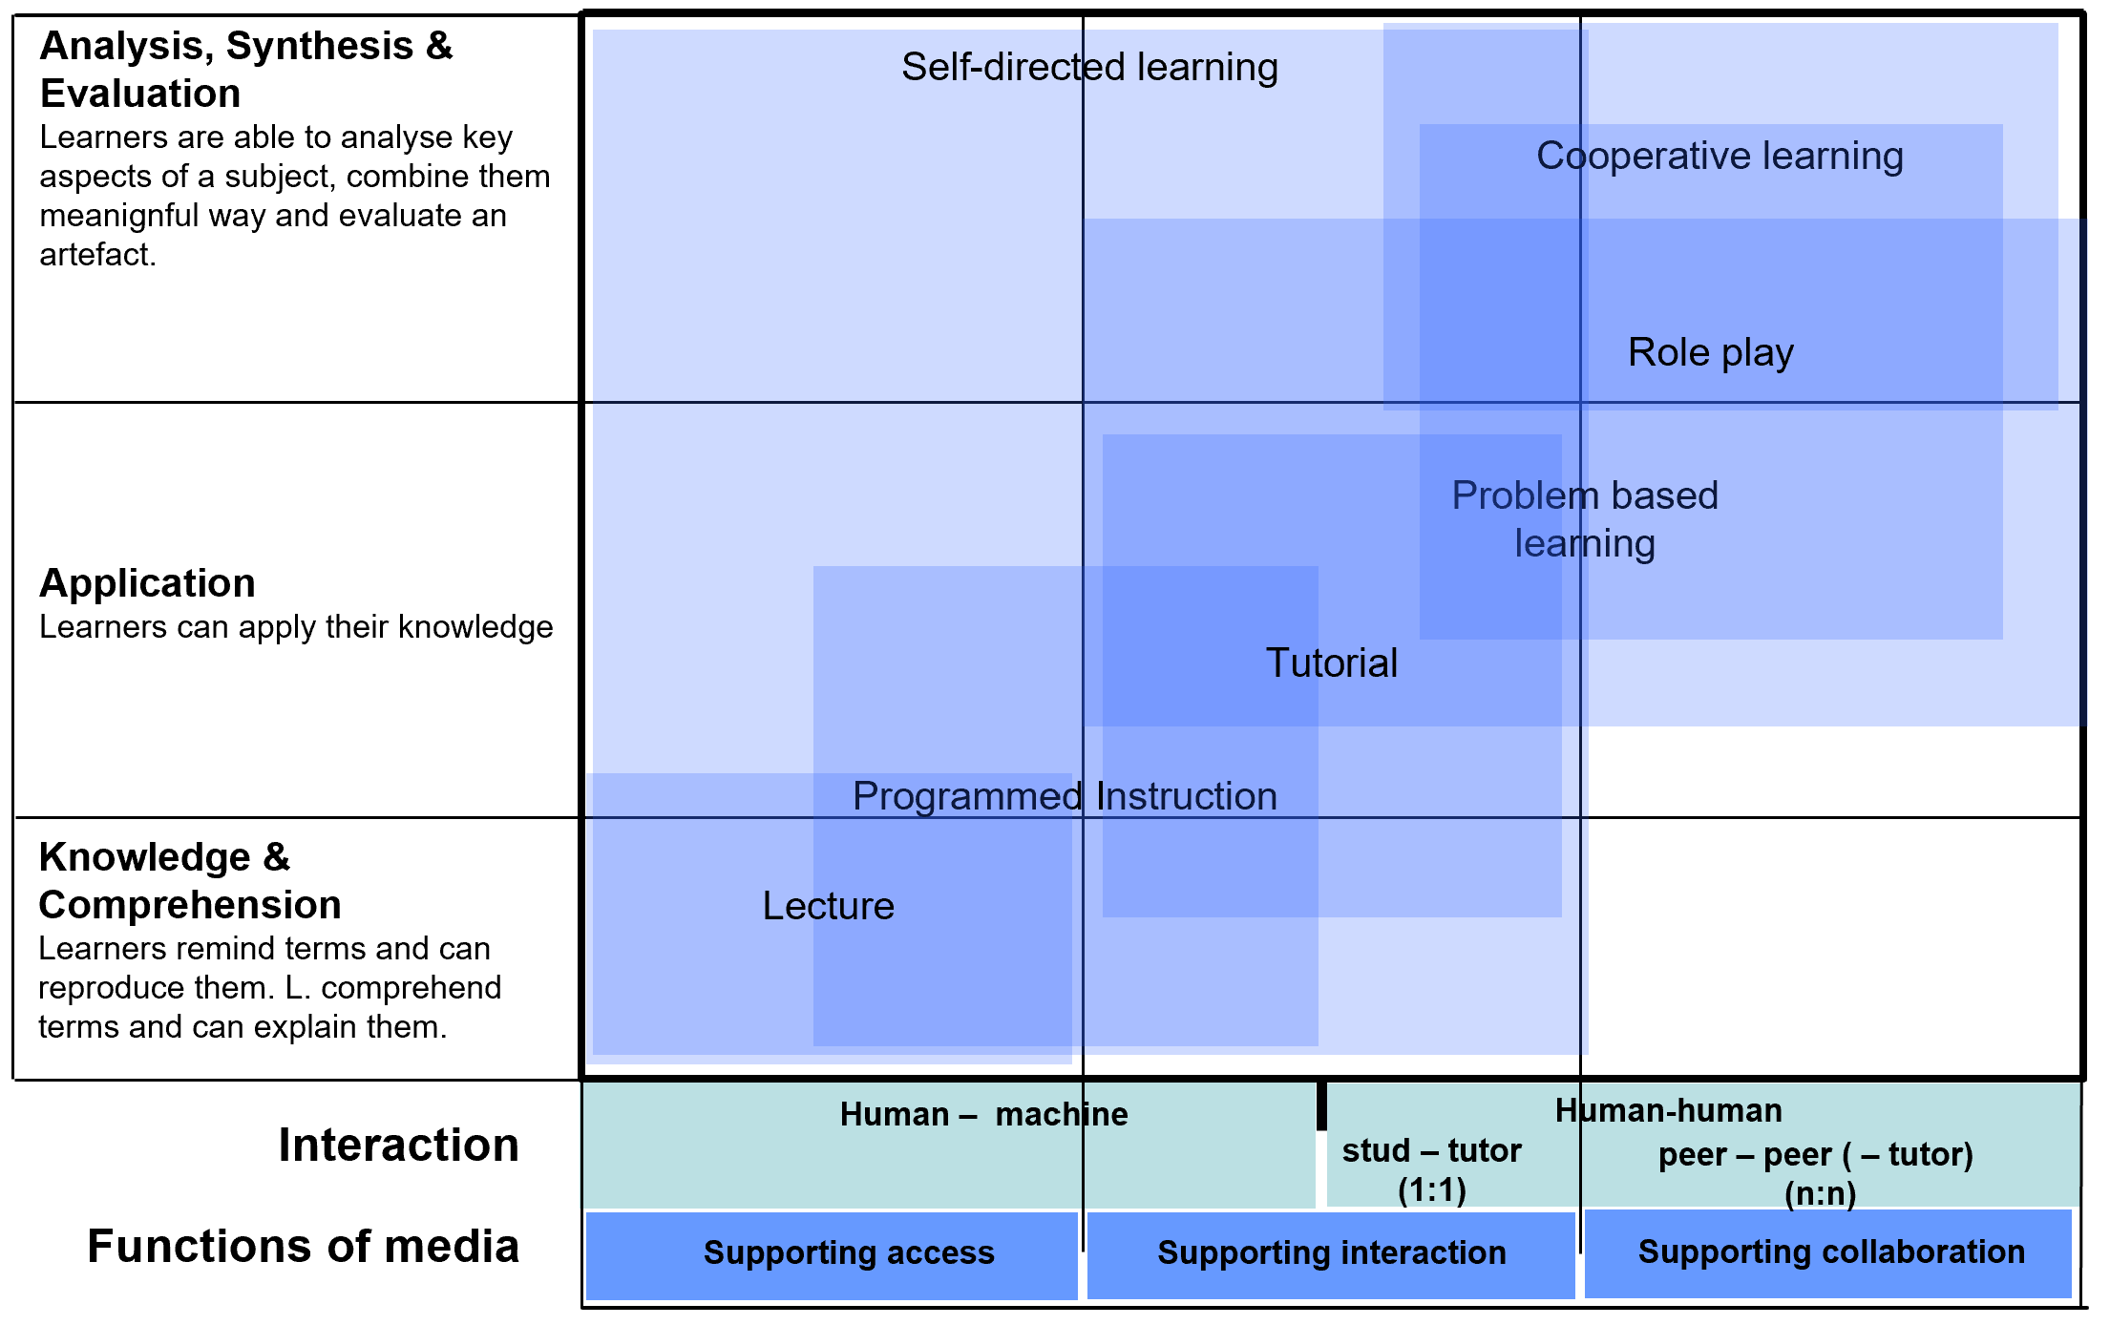
C) ICT4TVET Landscape

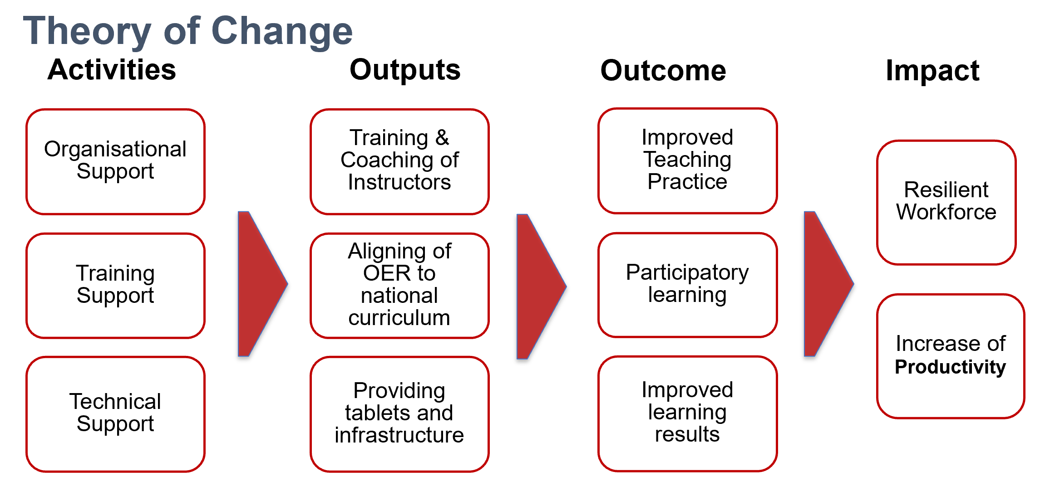
D) Example of the structure of a Theory of Change

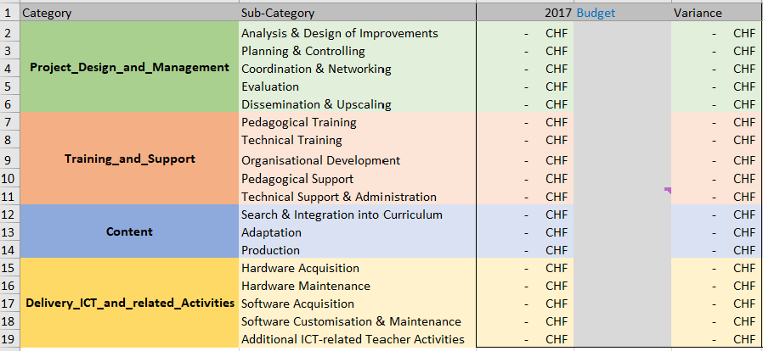
E) ICT4TVET Costing Framework

E.g. based on UNICEF policy framework

